**Roasted Chicken Quinoa Power Bowl**

Posted on June 22, 2015 by Viance Nutrition

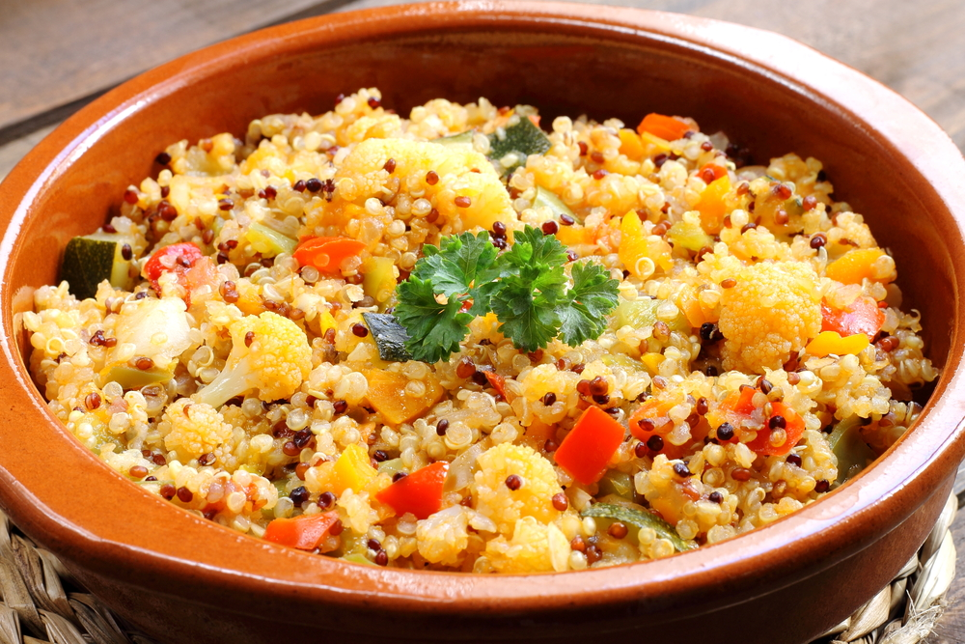

[Share Button](http://www.hupso.com/share/)

[http://static.hupso.com/share/buttons/PinExt.png](javascript:void(0))

A one-bowl wonder of quinoa, grilled chicken and veggies. It’s as perfect for a weeknight meal as it is served at a summer barbecue potluck.

Prep time: 15 minutes  
Cook time: 25 minutes  
Yield: 8 servings  
Serving size: Approximately 1 cup

[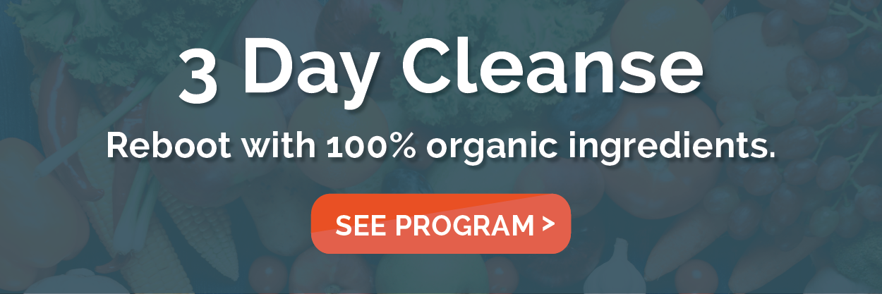](https://viance.com/products)

**Ingredients**

1 cup dry quinoa  
2 cups reduced-sodium vegetable broth  
¾ cup pesto (store bought is fine)  
12 oz grilled chicken breast (do in advance)  
4 Tbsp lemon juice  
1 tsp garlic powder  
1 tsp crushed red pepper  
1 tsp paprika  
1 tsp onion powder  
3 tsp extra virgin olive oil  
2 cups kale, chopped  
2 cups cauliflower, chopped  
2 cups carrots, chopped  
3 Tbsp fresh garlic, minced  
¼ tsp salt  
¼ tsp black pepper  
2 — 14.5 oz cans of crushed tomatoes  
Some cilantro leaves for garnish

**Instructions**

In a saucepan, combine dry quinoa and chicken broth. Cover and bring to a boil. Once boiling, reduce to simmer for 15 minutes. Remove from heat and set aside.

In a large sealable baggie, place grilled chicken breast, lemon juice, garlic powder, crushed red pepper, paprika and onion powder. Seal bag and shake, set aside.

In a large pot over medium-low heat add olive oil, kale, cauliflower and carrots.

Sauté until carrots are al denté, add garlic, salt and pepper and mix well.

Add tomatoes, quinoa, chicken mixture and combine. Cook for 2 minutes. Stir in pesto. Garnish with cilantro.

**Nutrition Information**

Per Serving Approximately 1 cup:  
Calories: 297  
Fat: 13g  
Carbohydrates: 29g  
Fiber: 6g  
Sugar: 7g  
Protein: 15g